Job Description (Part 1)

Post
Job Title | Stronger Roots Nottingham - Volunteering and Lived Experience Coordinator
Job Holder | New 2-year fixed term contract
Location | Based in Double Impact’s Friar Lane premises, Nottingham NG1
Hours | 0.5 FTE (2.5 days)
Reports to | Stronger Roots Nottingham Initiative Lead

Double Impact Services
Our Mission | INSPIRING CHANGE AND POSITIVE CHOICE  Double Impact is a registered charity and not for profit lived experience recovery organisation (LERO), established in 1998.  Our Mission is to provide quality services that promote recovery and community integration for people who have experienced problematic drug and alcohol use. This is achieved by providing opportunities for sustainable recovery, personal development, volunteering and work experience.  We believe that with the right support everybody can recover and that in recovery anything is possible.
Stronger Roots Nottingham Initiative | Double Impact is leading the Stronger Roots Project in partnership with Nottingham City Council to transform Nottingham into an Inclusive Recovery City (IRC). This initiative aims to combat stigma and foster an environment where individuals in recovery are fully integrated into society. An Inclusive Recovery City inspires and engages local civic and political figures, employers, universities, families and recovery champions within diverse communities to become part of a city-wide landscape which:  - Supports and celebrates recovery;  - Where there are opportunities and options for people to access a diverse and attractive range of recovery resources;  - Where people in recovery give back, not only to the recovery community but to the city or town, creating a feeling of hope and connection across the area.  - Attracts people towards recovery at an earlier stage through celebrating and raising its visibility  The initiative resources peer-led and peer-delivered support, key elements in creating a robust Recovery Oriented System of Care and presents an opportunity for Nottingham to become a beacon of inclusive recovery.  Progress to date  The project has been running since August 2024 and has a strong group of Core Partners, who meet regularly and a positive profile in the city. Nottingham is well on the way to achieving IRC status, recognised by the IRC UK Board. However, there is much more to do and this role will be key in ensuring that the project achieves its full potential.
Our Values | 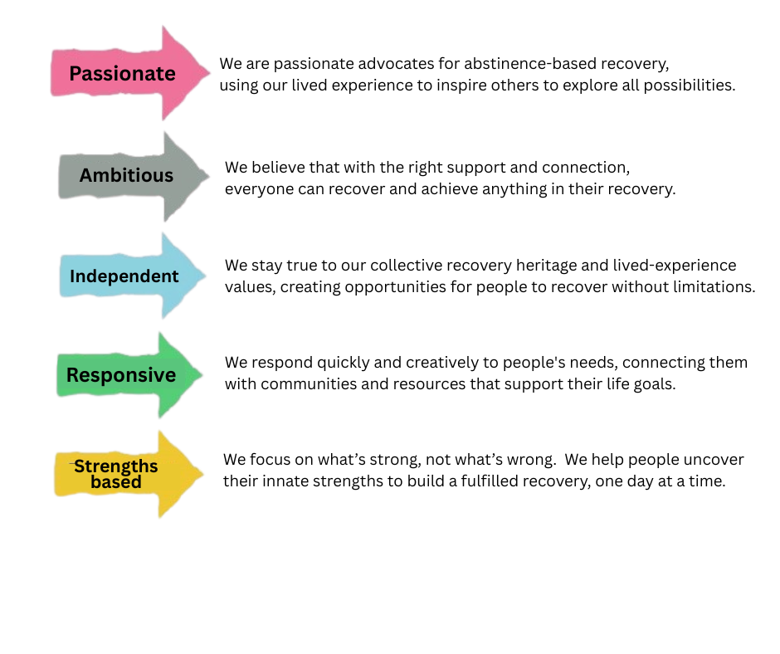

Job Profile
Purpose of Job | The Coordinator will be responsible for translating community interest into active participation. By engaging those with lived experience and those who have completed Recovery Ally training, this role will expand the project's reach and impact through a robust network of volunteers and champions.

Job Description (Part 2)

Duties & Key Responsibilities
Key Responsibilities: | - Volunteer Pathway Development: Follow up with participants of the Recovery Ally training to transition them into active volunteering or champion roles.  - Lived Experience Engagement: Proactively engage with individuals and families in recovery to involve them in the project’s work.  - Opportunity Creation: Collaborate with the project team to identify, design, and implement new volunteering opportunities across the city.  - Community Integration: Help reduce stigma by facilitating the visibility of recovery champions in diverse community settings.  - Record Keeping: Maintain accurate records of volunteer activity, outcomes, and feedback to support programme evaluation.
Administration & Systems  (supported by Double Impact HR Manager). | - Implement risk assessment procedures to ensure the safety of staff, volunteers, and clients.  - Adhere to Equality of Opportunity policies and anti-discriminatory practices.  - Ensure all aspects of confidentiality and GDPR are maintained.  - To maintain electronic records to enable reporting of key outcomes and outputs.  - To contribute to newsletters, comms/marketing content and project evaluation as required

Job Specification (Part 3)

 | Essential
Education & Experience | - Essential: Experience in volunteer coordination or community engagement.  - Essential: Experience working directly with people with lived experience of substance use and recovery.  - Essential: Experience of working with people from a range of social, cultural, and ethnic backgrounds.  .
Knowledge & Abilities | - Passion: Strong commitment to promoting Recovery Capital for Nottingham citizens.  - IRC Principles: Understanding of the Inclusive Recovery Cities movement and the role of Lived Experience within it.  - Boundaries: Ability to maintain professional boundaries while working closely with the recovery community.  - Organisation: Ability to organise and prioritise own workload effectively.
Skills & Teamwork | - Adaptability: Flexibility to accommodate changing needs in a dynamic project environment.  - IT Literacy: Excellent IT skills for record-keeping and communication.  - Collaboration: A willingness to enthusiastically support the team in pursuit of collective project goals.  - Be willing to take on jobs to balance the team workload
Personal Integrity | - Be trustworthy and respectful  - Be personally well presented  - Maintain excellent time-keeping and attendance  - Be professional at all times

Terms & Conditions (Part 4)

Terms & Conditions of Employment
Position | Volunteering and Lived Experience Coordinator (Stronger Roots)
Location | 0.5 FTE (2.5 days) — Monday-Friday (occasional evenings/weekends)
Hours | 2-year fixed term
Contract Type | £15,000 pro rata (£30,000 full-time equivalent)
Salary | 6 Months (reviewed at 3 months)
Pension | Auto-enrolment into work pension scheme
Probation Period | 6 Months (reviewed at 3 months)
Holiday Entitlement | 27 days + Bank Holidays (all pro rata for part-time)
Notice | 1 month

Acceptance - The above job description is not all encompassing and is subject to regular review
Signature of Post Holder | I have read and accept the duties and responsibilities outlined in this job description.  Signature: _________________________________________  Print Name: _________________________________________  Date: __________________________

N.B TO BE SIGNED THROUGH PEOPLE HR

